Resource: Excerpts from “Powerful New Year Prayers to Renew Your Heart and Mind in the Year Ahead” (Christianity.com)
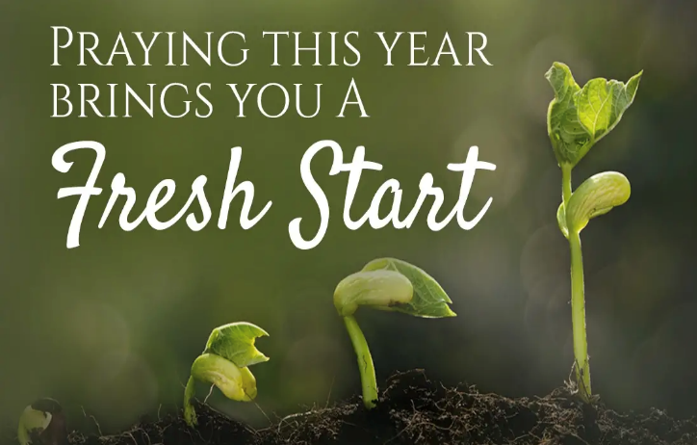
The arrival of a new year brings a great opportunity to renew our faith and love for God and Jesus. It's also a wonderful time to renew the joy of salvation in our hearts, as a new creation in Christ. "Therefore, if anyone is in Christ, he is a new creation. The old has passed away; behold, the new has come" (2 Cor. 5:17). Whether 2020 brought you success, fulfillment, and joy or you faced grief, setbacks, and struggle, you can look ahead to 2021 with hope. Jeremiah 29:11 tells us "for I know the plans I have for you," declares the Lord, "plans to prosper you and not to harm you, plans to give you hope and a future."

Let's end this year with a thankful heart and start the new year with peace and faith. Let us release the bitterness and frustrations of the past year. Let us move into the next year knowing that God loves us and wants the best for us. Let's pray that the new year will be focused on healing ourselves through repentance and the renewing of our minds. We were not meant to do life alone! We can bring the light of hope into our own heart, home, and world.

"Do not be conformed to this world, but be transformed by the renewal of your mind, that by testing you may discern what is the will of God, what is good and acceptable and perfect." ~ Romans 12:2

May these prayers for the new year bring you comfort and gratitude as you step into the next year! Share them with your friends and family to inspire the hearts of those you love most. God Bless!

For Peace in the New Year
At the start of each day, help us to recognize you above all else. Enlighten the eyes of our heart that we might see you, and notice how you're at work through our lives. Give us the wisdom to make the best choices, fill us with a desire to seek after you more than anything else in this world. Let your Spirit and power breathe in us, through us, again, fresh and new. Thank you that you are greater than anything we may face in our day. Thank you that your presence goes with us and that your joy is never dependent on our circumstances, but it is our true and lasting strength, no matter what we're up against. We ask that your peace lead us, that it would guard our hearts and minds in you. We ask for your grace to cover our lives this day. We love you Lord...we need you. In Jesus' Name, Amen." – (Debbie McDaniel)

Prayer for Hope After a Difficult Year
Dear God, Thank you for helping us to make it through this difficult year. Thank you that you’ve carried us through the uncertainty of deep waters, through the flames of trials, and through the pain of hard losses. We are constantly aware of how much we need you, your grace, your strength, your power working through even the toughest days. Fill us with your joy and the peace of your Spirit. Direct our hearts and minds towards you. Thank you for your reminder that both in seasons of celebration and in seasons of brokenness, you’re still with us. For you never leave us. Thank you for your daily powerful Presence in our lives, that we can be assured your heart is towards us, your eyes are over us, and your ears are open to our prayers. Thank you that you surround us with favor as with a shield, and we are safe in your care. We choose to press in close to you today and keep you first in our hearts and lives. Without You, we would surely fail, but with you, there is great hope. Thank you for your healing power, thank you for bringing us into this new season up ahead. We look forward to all that You still have in store. In Jesus’ Name, Amen. – (Debbie McDaniel)

Bible Verses for the New Year - Scripture Quotes about renewal and hope in Christ.
Isaiah 43:18-19 - “Remember not the former things, nor consider the things of old. Behold, I am doing a new thing; now it springs forth, do you not perceive it? I will make a way in the wilderness and rivers in the desert.

2 Corinthians 5:17 - Therefore, if anyone is in Christ, he is a new creation. The old has passed away; behold, the new has come.

Hebrews 10:24-25 - And let us consider how to stir up one another to love and good works, not neglecting to meet together, as is the habit of some, but encouraging one another, and all the more as you see the Day drawing near.

Jeremiah 29:11 - For I know the plans I have for you, declares the Lord, plans for welfare and not for evil, to give you a future and a hope.

